**PAPER TITLE, FONT TYPE-CAMBRIA, BOLD, FONT SIZE 14**

**First Author *1, Second Author*2, Third Author*3 (Font-Cambria, Bold, Font Size -12)**

*1Affiliation, Department, Institute, City, State, Country (Font Size -11)

*2Affiliation, Department, Institute, City, State, Country

*3Affiliation, Department, Institute, City, State, Country

(Ex- Professor, Department of ABC Engineering, Institute Name, City, state, Country)

**ABSTRACT (Font-Cambria, Bold, Font Size -12)**

An abstract is a summary of entire paper should be written in Times new roman with font size- 10. The abstract should not be more than 200 words and written in single paragraph. This electronic document is a “live” template. The abstract includes the overall purpose of the study you investigated, the basic design of the study, results of your analysis and brief summary of your interpretations and conclusion

**Keywords:** Analysis, investigation, research (5-6 Keywords, Font-Cambria, Font Size – 10).

1. **INTRODUCTION (Font-Cambria, Bold, Font Size -12)**

The introduction should be typed in Times New with font size 10. In this section highlight the importance of topic, making general statements about the topic and Presenting an overview on current research on the subject. The simplest way is to replace(copy-paste) the content with your own material. Your introduction should clearly identify the subject area of interest.

1. **METHODOLOGY**

Method and analysis which is performed in your research work should be written in this section. A simple strategy to follow is to use keywords from your title in first few sentences.

**Subheading**

Subheading should be Font Size- 10pt, Font Type- Cambria, justified.

**Subheading**

Subheading should be 10pt Times new Roman,

1. **MODELING AND ANALYSIS**

Model and Material which are used is presented in this section. Table and model should be in prescribed format.

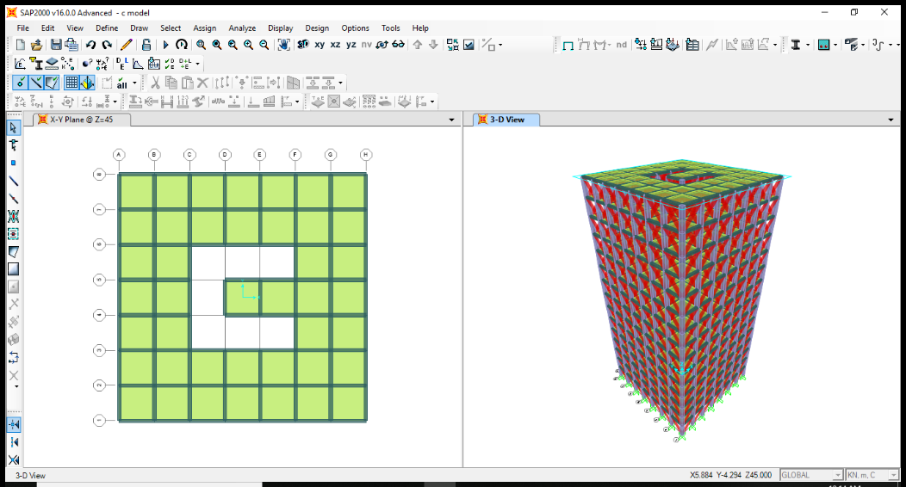

**Figure 1:** 3D view of building.

1. **RESULTS AND DISCUSSION**

The results and discussion may be combined into a common section or obtainable separately. They may also be broken into subsets with short, revealing captions. An easy way to comply with the conference paper formatting requirements is to use this document as a template and simply type your text into it. This section should be typed in character size 10pt Times New Roman.

**Table 1.** Comparison of displacement of all 4 cases

|  |  |  |  |
| --- | --- | --- | --- |
| SN. | Model Type | Seismic Zone | Displacement |
| 1 | Model-A | 4 | 10.044 mm |
| 2 | Model-B | 4 | 11.335 mm |
| 3 | Model-C | 4 | 10.248 mm |
| 4 | Model-D | 4 | 11.364 mm |
| 5 | Model-E | 4 | 12.16 mm |
| 6 | Model-F | 4 | 10.99 mm |
| 7 | Model-G | 4 | 11.29mm |
| 8 | Model-H | 4 | 13.20mm |
| 9 | Model-I | 4 | 9.2mm |

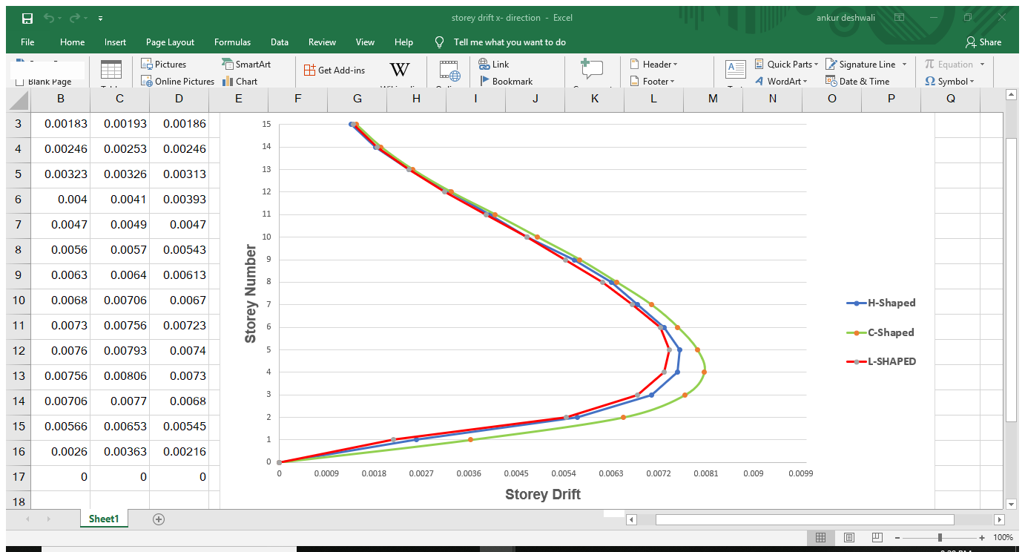

**Figure 2:** Name of Graph (Font size-10)

1. **CONCLUSION**

All the main points of the research work are written in this section. Ensure that abstract and conclusion should not same. Graph and tables should not use in conclusion.

**ACKNOWLEDGEMENTS (optional)**

The authors can acknowledge professor, friend or family member who help in research work in this section.

1. **REFERENCES**
2. Holmes, M. (1961). Steel frames with brickwork and concrete infilling, Proceedings of the Institution of Civil Engineers, 473-478.
3. Smith, B. S. and Carter, C. (1969). A method of analysis for infilled frames, Proceedings of the Institution of Civil Engineers, Vol.7218, 31-48.
4. Mainstone, R. J. and Weeks, G. A. (1970). The influence of bounding frame on the racking stiffness and strength of brick walls, in Proc. 2nd International Brick Masonry Conference, Building Research Establishment, Watford, England, 165-171.
5. ATC (1996). Seismic Evaluation and retrofit of Concrete buildings, Vol. 1, ATC-40 Report, Applied Technology Council, Redwood City, California.
6. Federal Emergency Management Agency (1998). Evaluation of Earthquake Damaged Concrete and Masonry Wall Buildings: Basic Procedures Manual, FEMA-306, Applied Technology Council, Washington DC.
7. FEMA-356 (2000). Prestandard and Commentary for the Seismic Rehabilitation of Buildings, Building Seismic Safety Council, Washington DC.